* + Regular Expression in JMeter (continued)
  + Dynamic Values Extraction in JMeter with Realtime Use Cases Examples: -
  + The General Expression
  + E.g. of Multiple Values Extraction by Ignoring Middle Values
  + E.g. of Escape Character
  + E.g. of Extracting a Value in Newline
  + E.g. of Extracting a Value with Left Boundary but No Right Boundary
  + E.g. of Extracting a Value with both Varying Left & Right Boundary
  + E.g. of Extracting the Single Value in Response with No Left & No Right Boundary
  + E.g. of Extracting Complete Response
  + E.g. of Extracting Response (Status) Code
  + E.g. of Extracting Response Message
  + E.g. of Extracting a Value from Response Header
  + E.g. of Extracting Complete Headers
  + E.g. of Capturing Last Dynamic Value (or Selection)
  + **__V() function**
  + Parameterization within Parameterization **OR** Nested Parameterization

The general expression: - **(.+?)** don’t use * we are using 80% this regex OR [(

1. **E.g. of Multiple Values Extraction by Ignoring Middle Values: - .+**

* Line concept.
* Hole response basically in one line.
* One line response.
* Coding wises this a one line.
* Let us say I need all the values.
* So many dynamic values in the line.

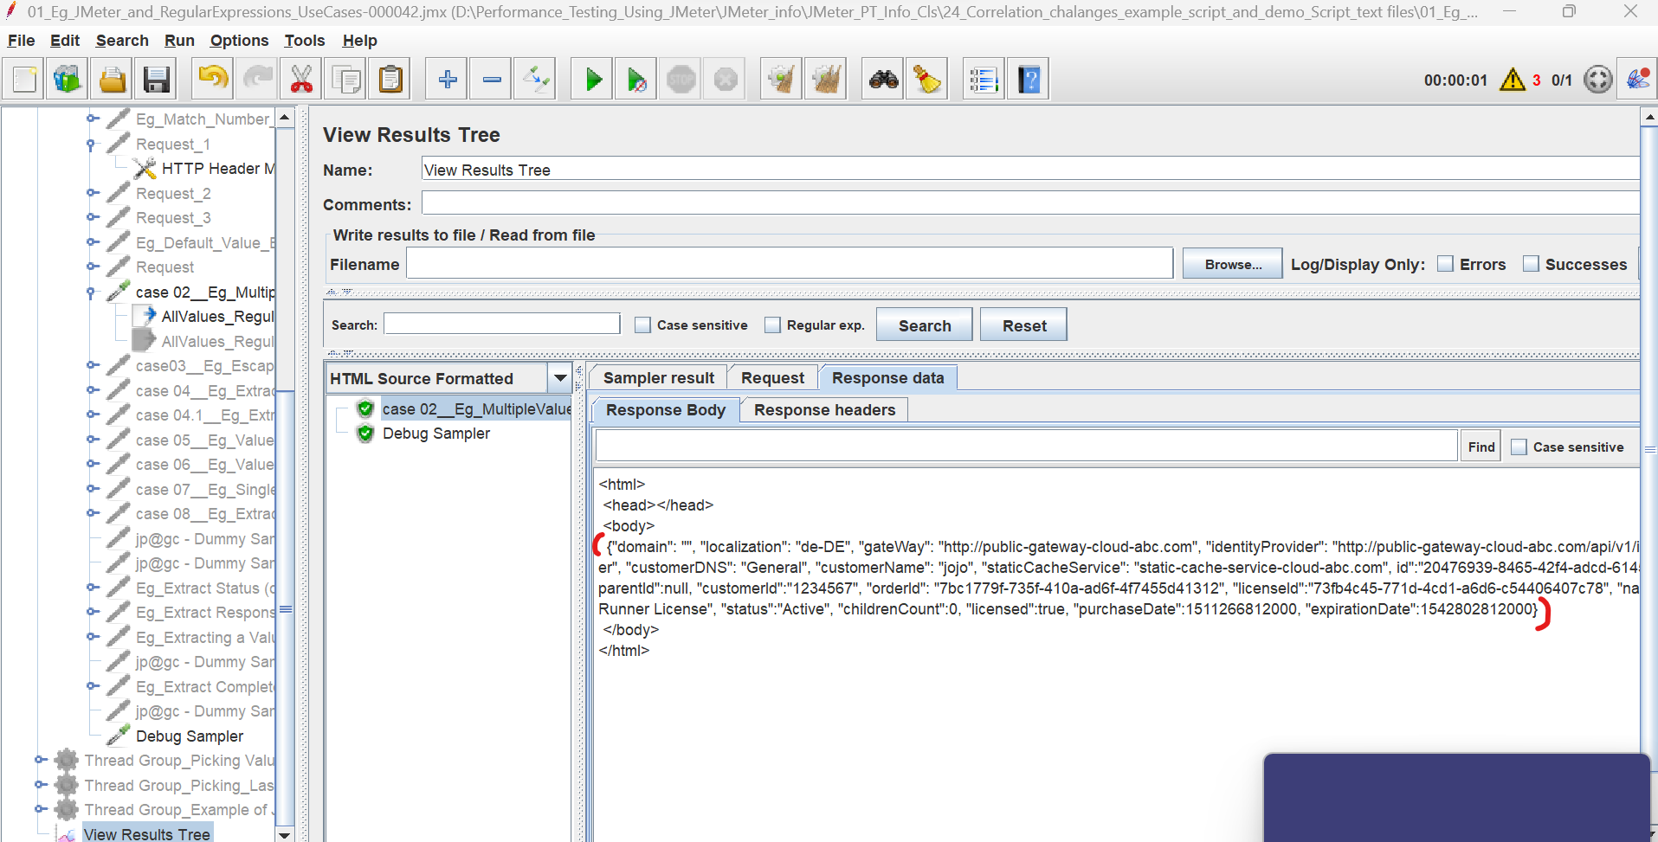

Around seven dynamic values are there

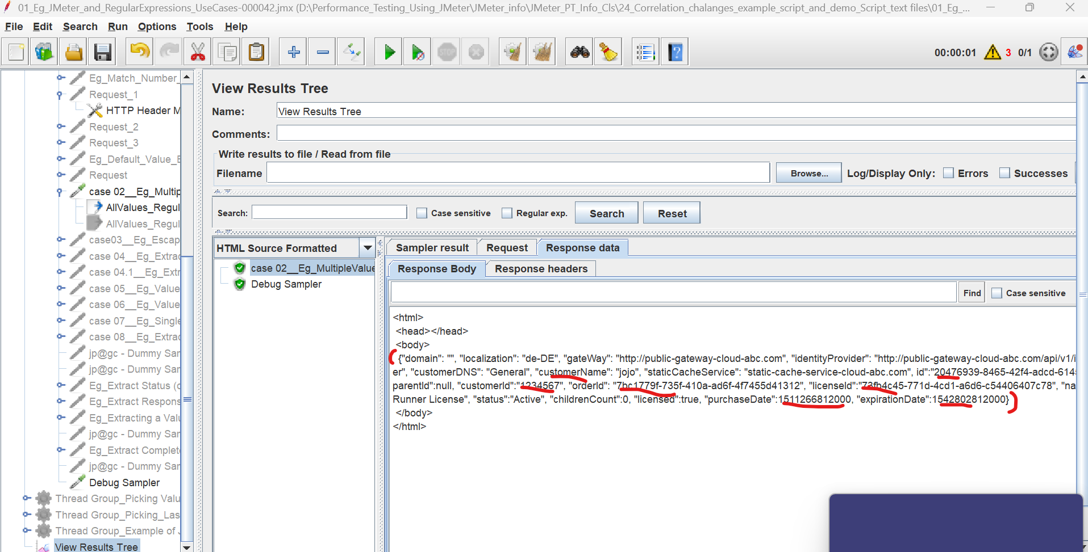

Jest copy the line

<html>

<head></head>

<body>

{"domain": "", "localization": "de-DE", "gateWay": "http://public-gateway-cloud-abc.com", "identityProvider": "http://public-gateway-cloud-abc.com/api/v1/identity-provider", "customerDNS": "General", "customerName": "jojo", "staticCacheService": "static-cache-service-cloud-abc.com", id":"20476939-8465-42f4-adcd-61455d9d830e", "parentId":null, "customerId":"1234567", "orderId": "7bc1779f-735f-410a-ad6f-4f7455d41312", "licenseId":"73fb4c45-771d-4cd1-a6d6-c54406407c78", "name":"HP LoadRunner License", "status":"Active", "childrenCount":0, "licensed":true, "purchaseDate":1511266812000, "expirationDate":1542802812000}

</body>

</html>

Past it in note pad

Extracting the dynamic values using with (.+?)

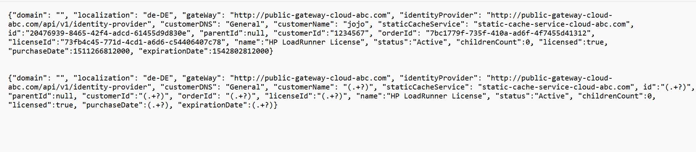

Copy the extracted value and past it regex test

And we are getting expected results.

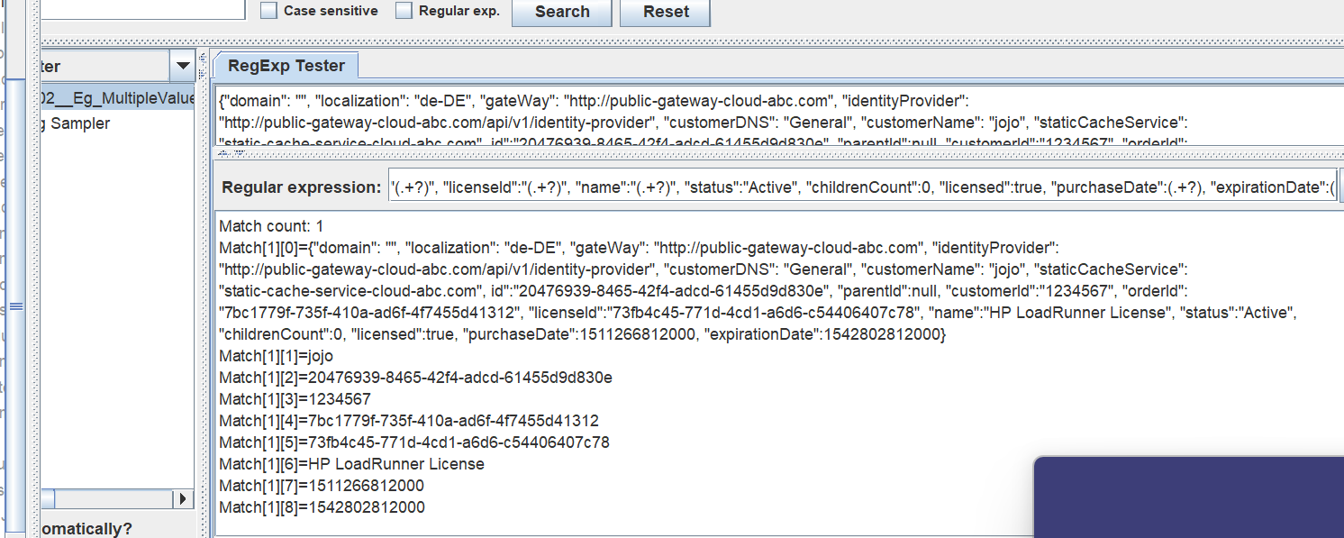

Add regex

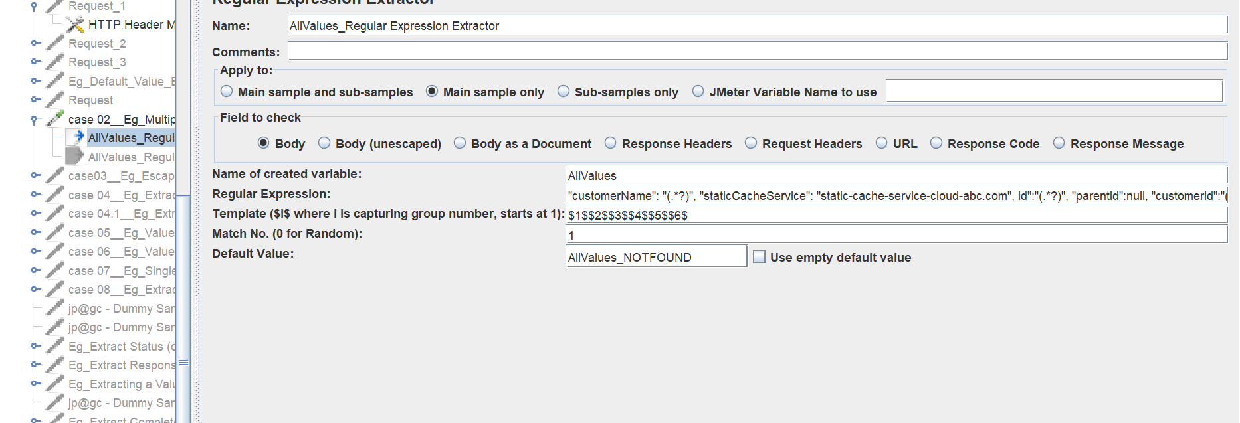

The special is

**Ignoring Middle Values**

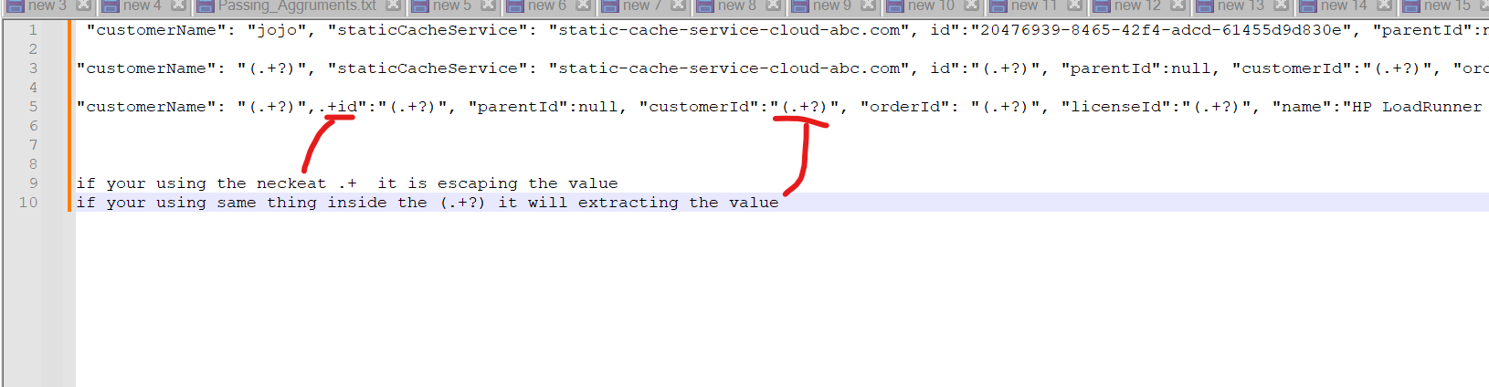

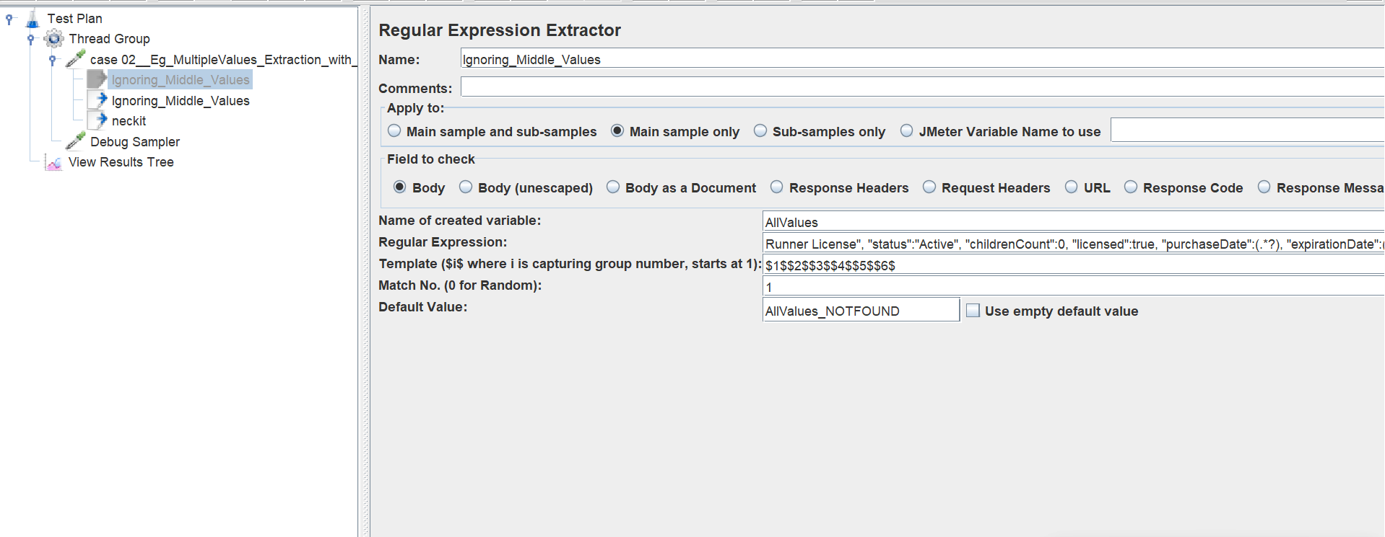

Case 3 E.g. of Escape Character

=========******=======

This is the response dynamic value

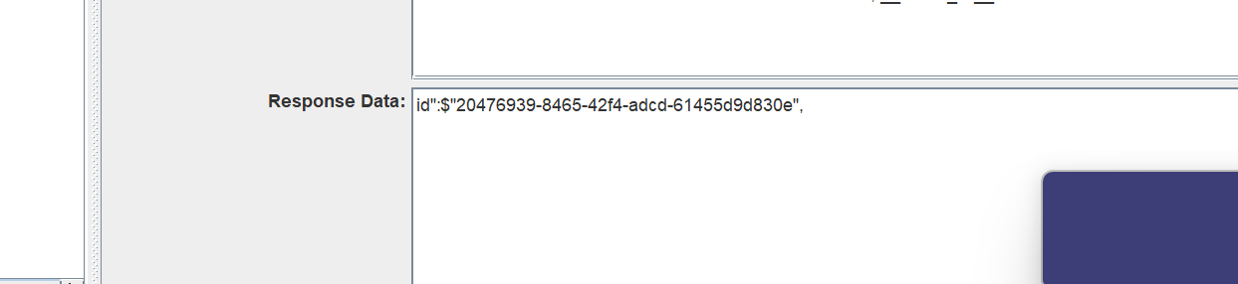

this is the response dynamic, entair responce --> id":$"20476939-8465-42f4-adcd-61455d9d830e",

prepare regex and test in regex test

id":$"(.+?)",

not working

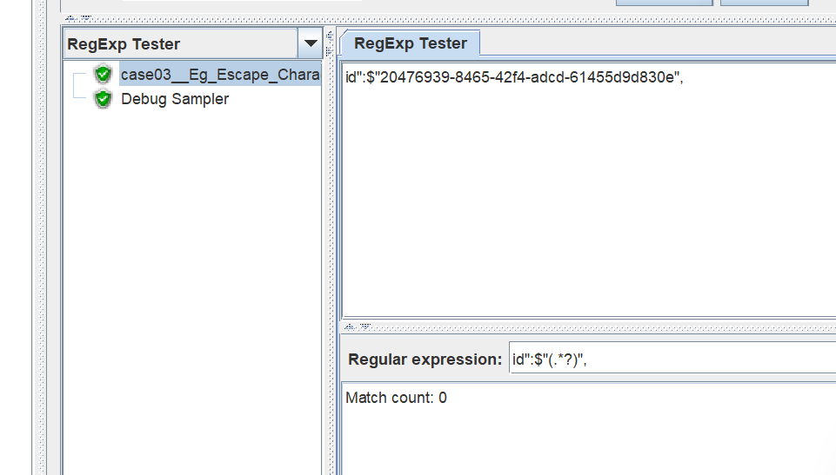

Whenever expression that you prepare, either left and side and right and side, if any of meta characters comes

$ this is meta character.

If any meta character comes regex directly fail.

$ is coming inside of the value

So, we have use escape concept here, you have to escape $ this

Before $ this you have give \

id":\$"(.*?)",

what are the meta characters🡪 this are the meta characters

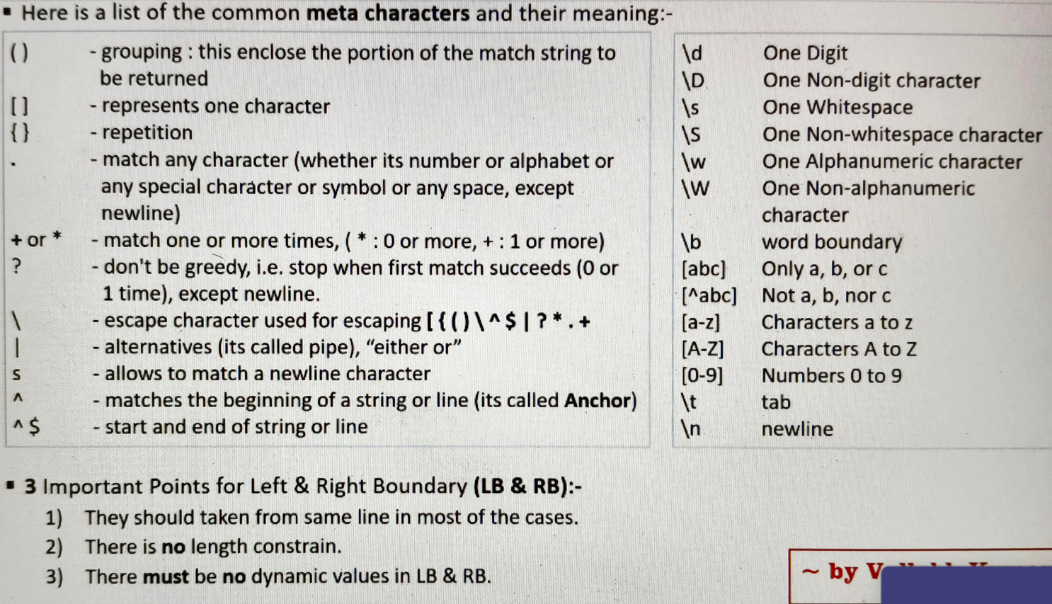

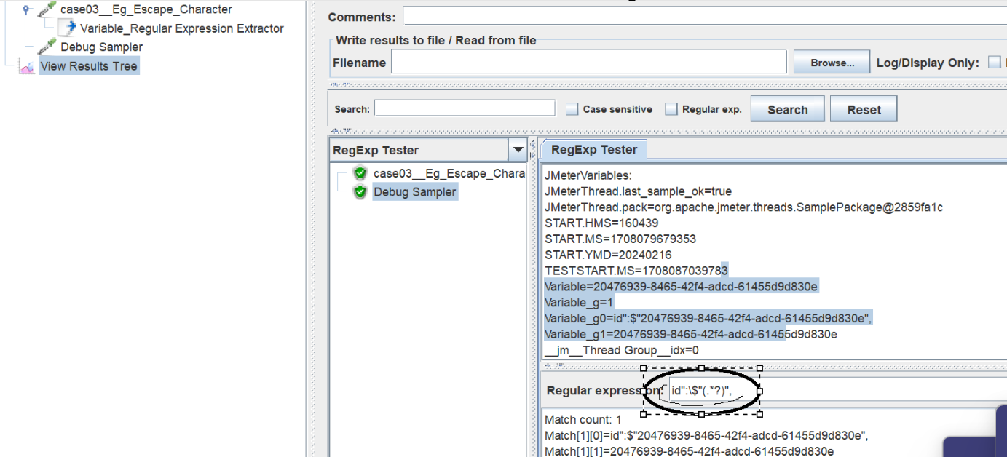

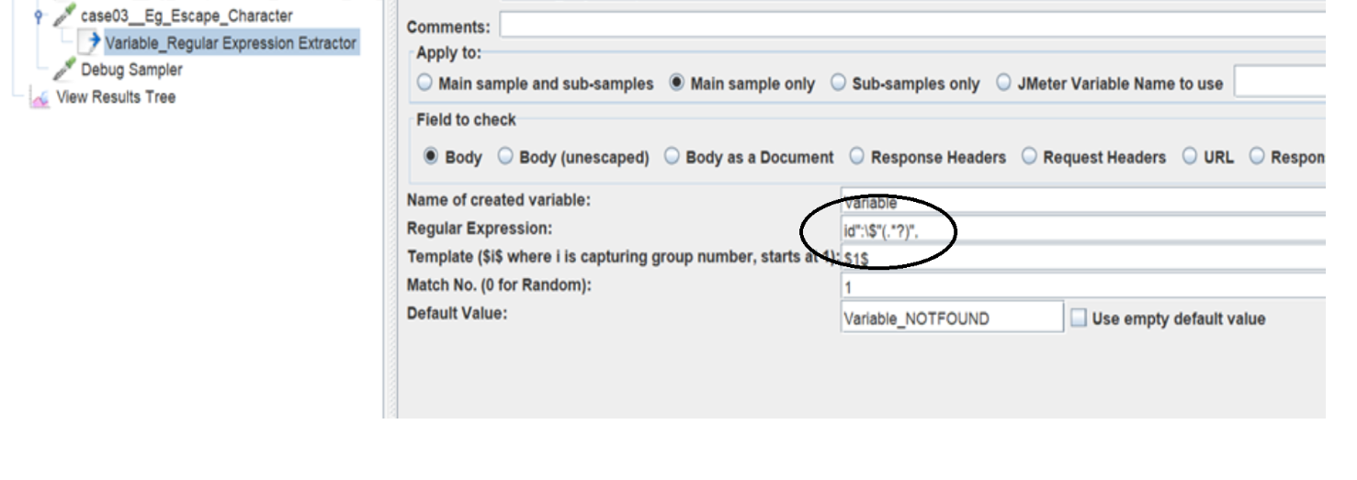

Case 3.1:- 



This is the one dynamic value.

nonce=JdHf1_8N-EdjZsERyIbqCIo4PTTuOU9RtrMFjRDfDfEAc\x26acr_values

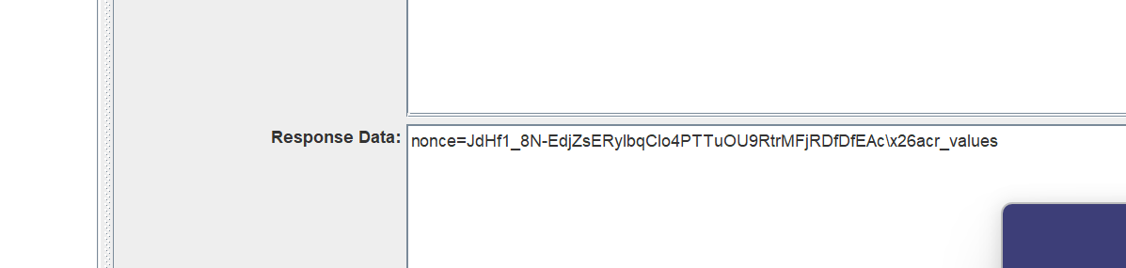

Preparing regex

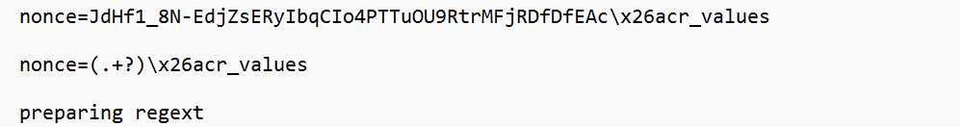

Regex test

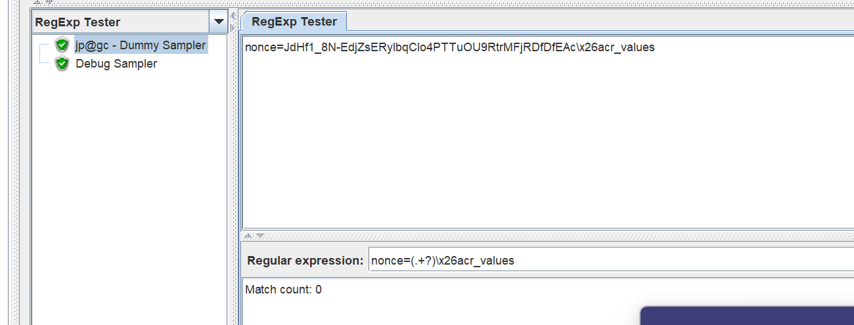

It is not working, match cunt 0, the reason is meta character

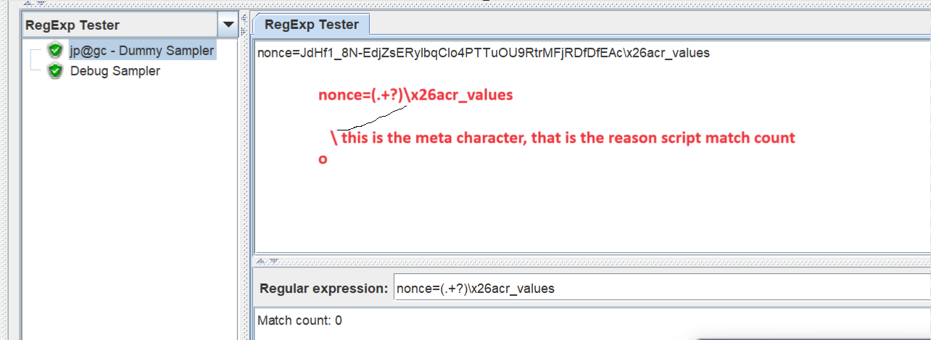

Now we are using escape character \

Now using escape character, match count coming 1

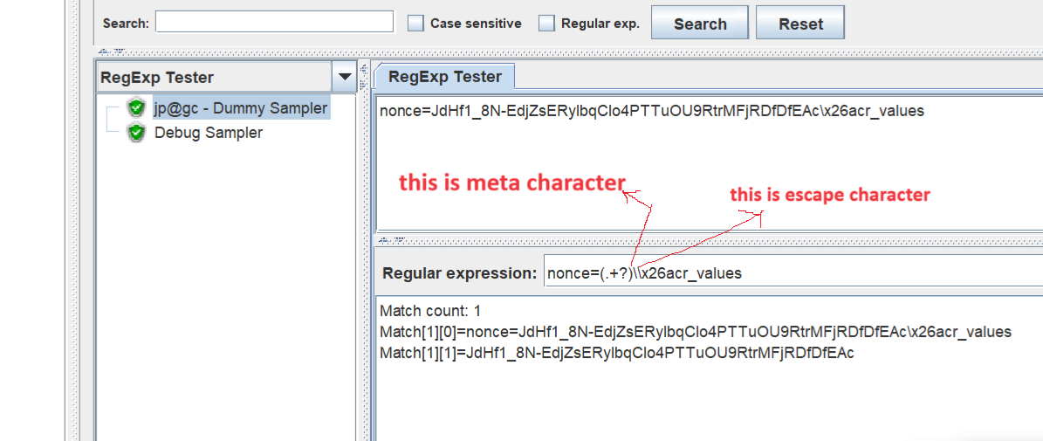

Working

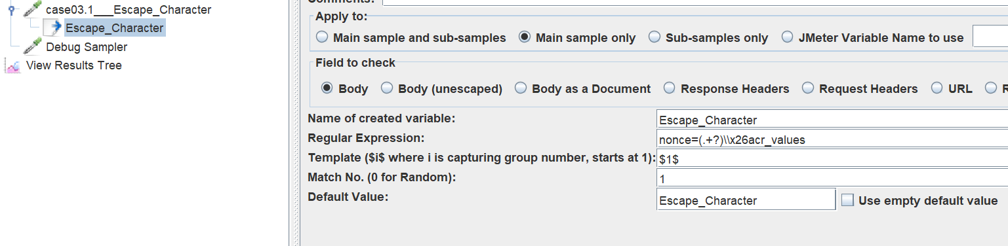

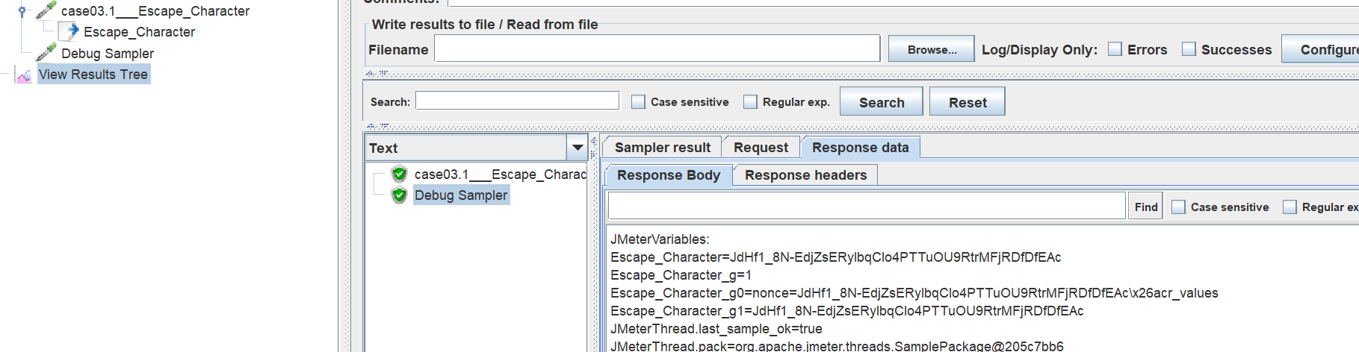

In Telugu note book

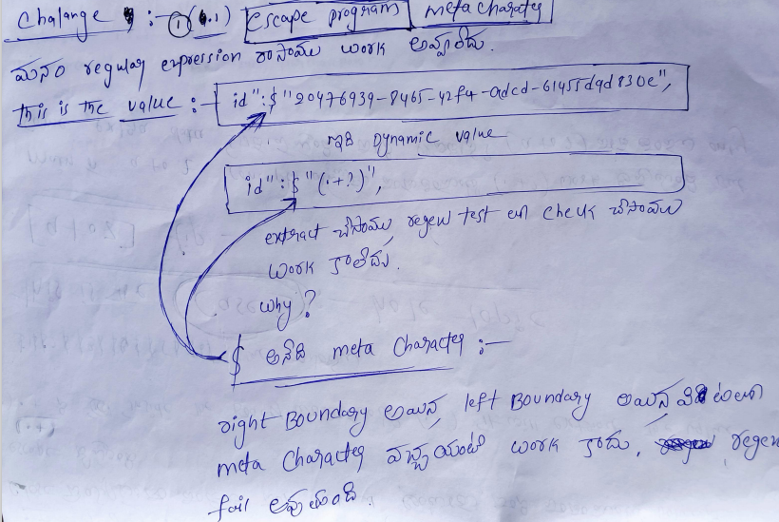

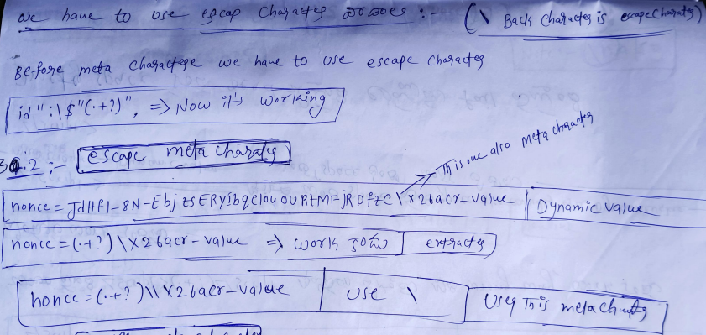

Extracting a Value in Newline

Some time there is value no left boundary and right boundary

This is response body in that we have dynamic value

This value don’t have any left and right bondaryes.

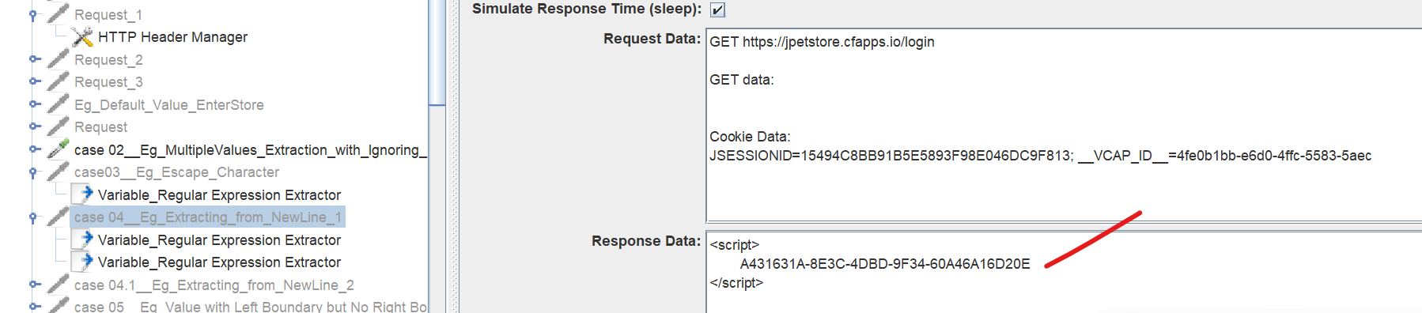

With that value three separate lines

Second line there is no LB and RB.

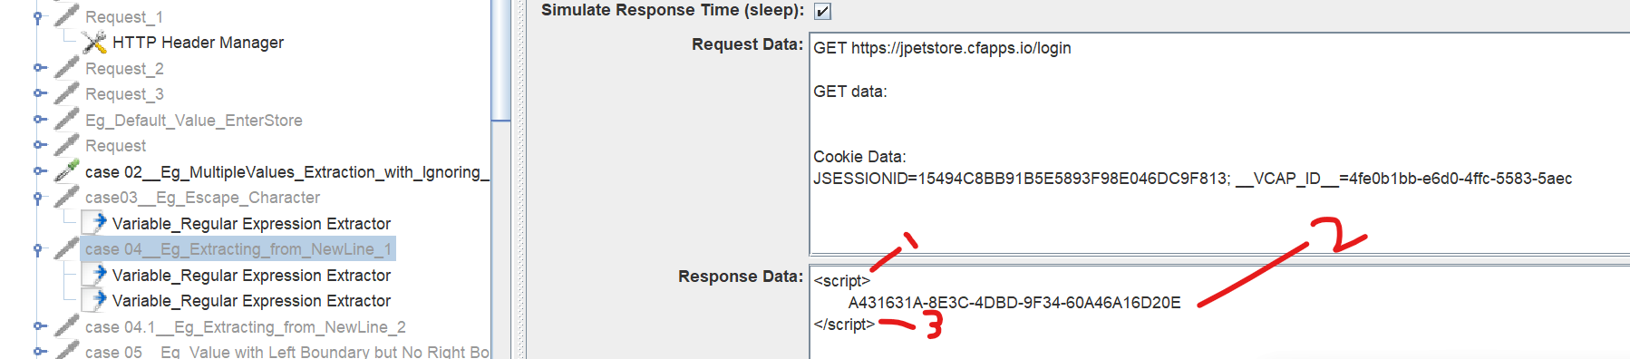

Most of the people do like, but This is wrong way

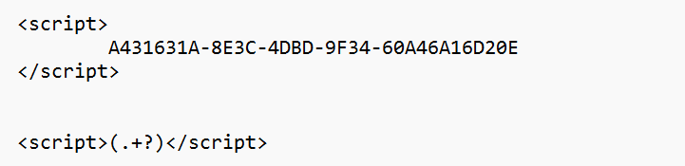

Match count 0

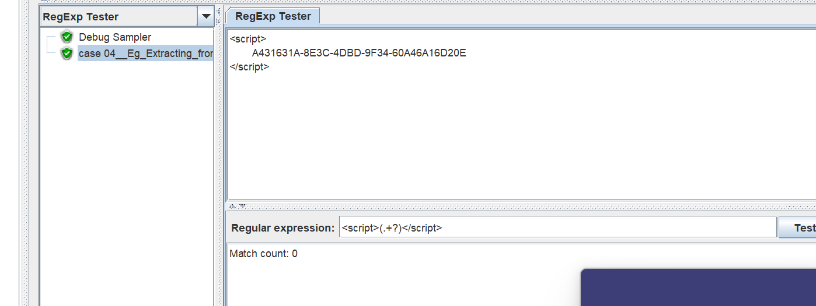

Let me explain

Space also acting boundary

Space is also acting as a boundary

We don’t know how much space

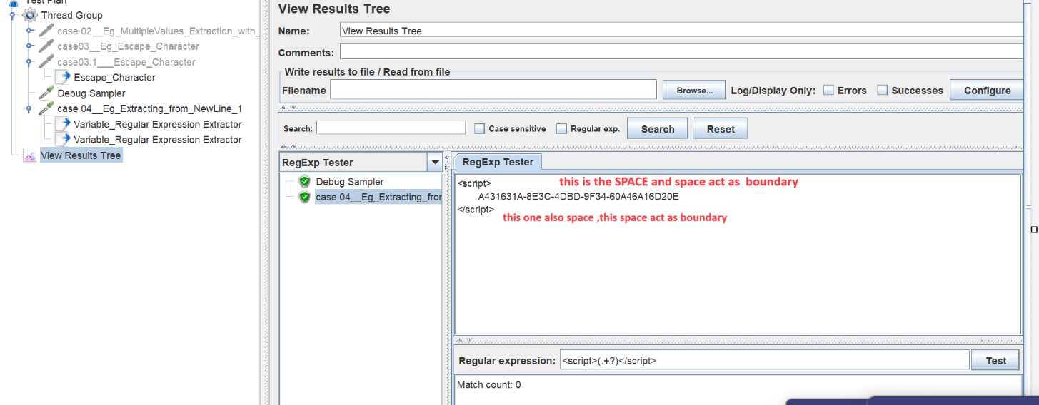

Solution is

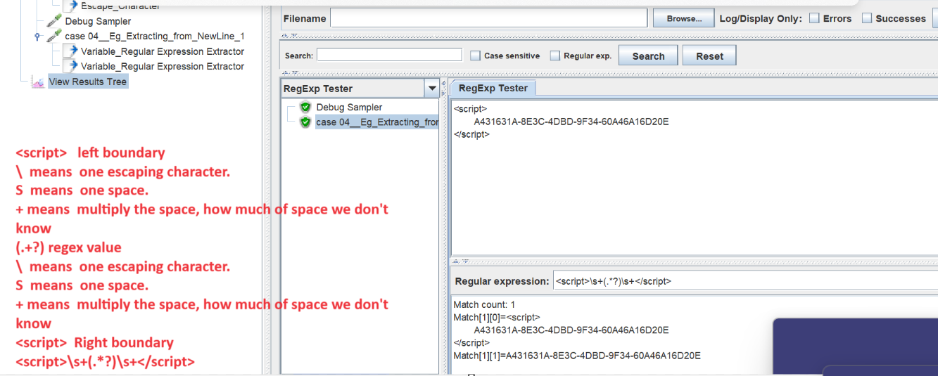

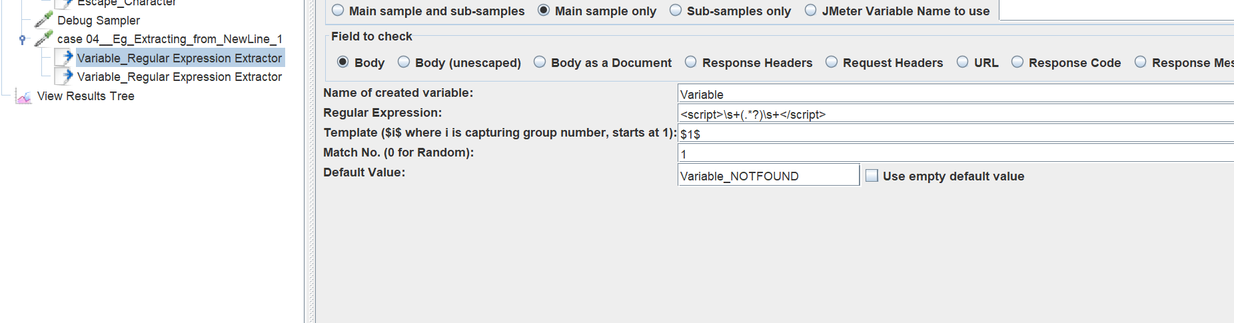

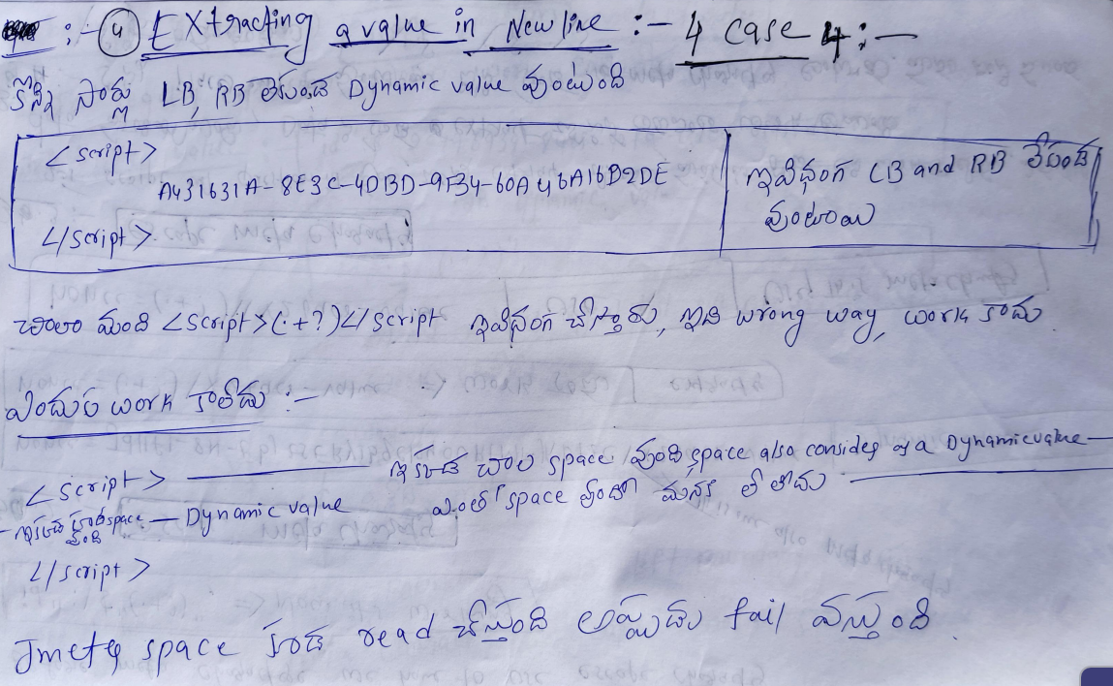

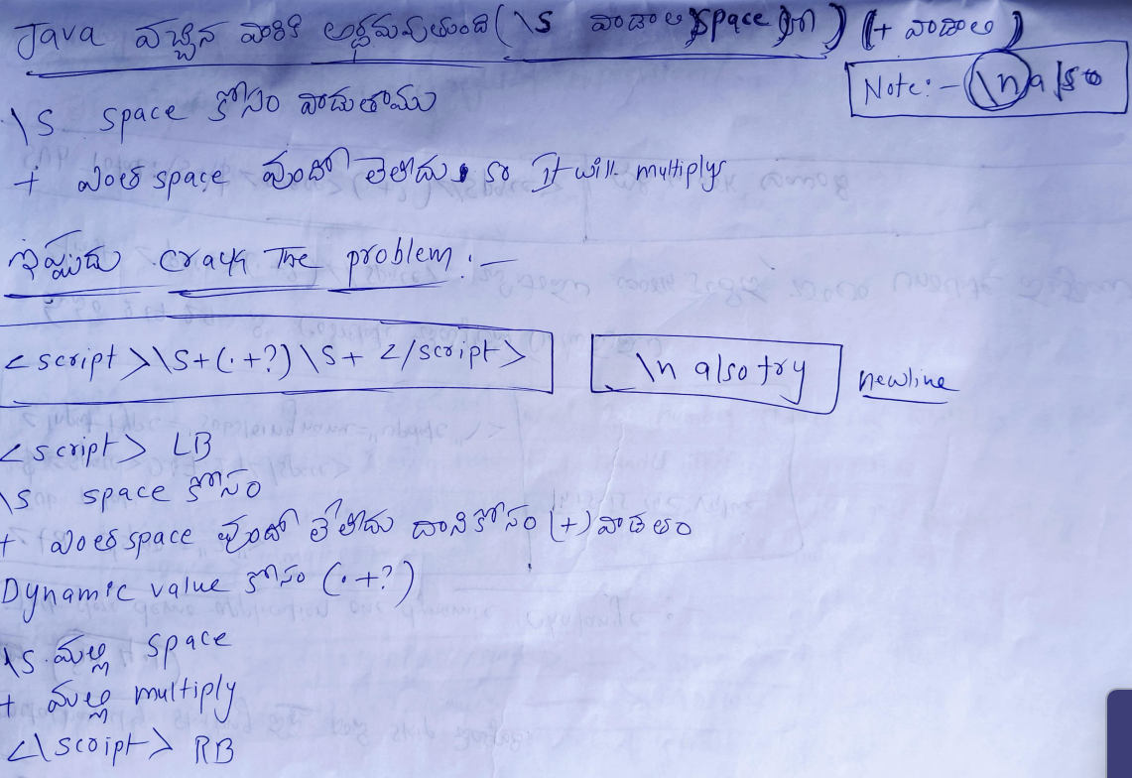

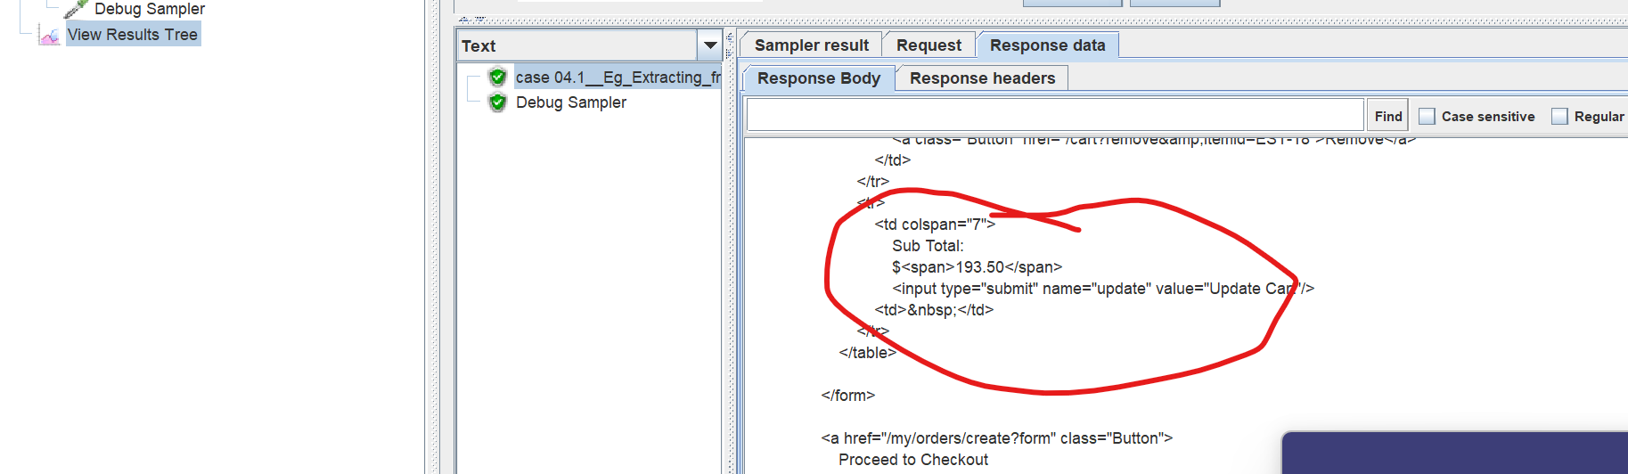

Writing note book: -

